Network Task:

Finding IP of the domain (guvi.in)

Answer: **172.67.70.207**

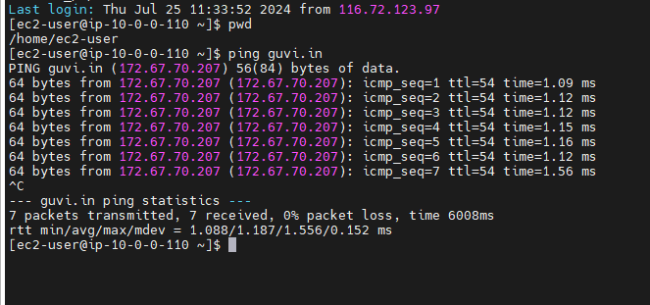

CPU usage:

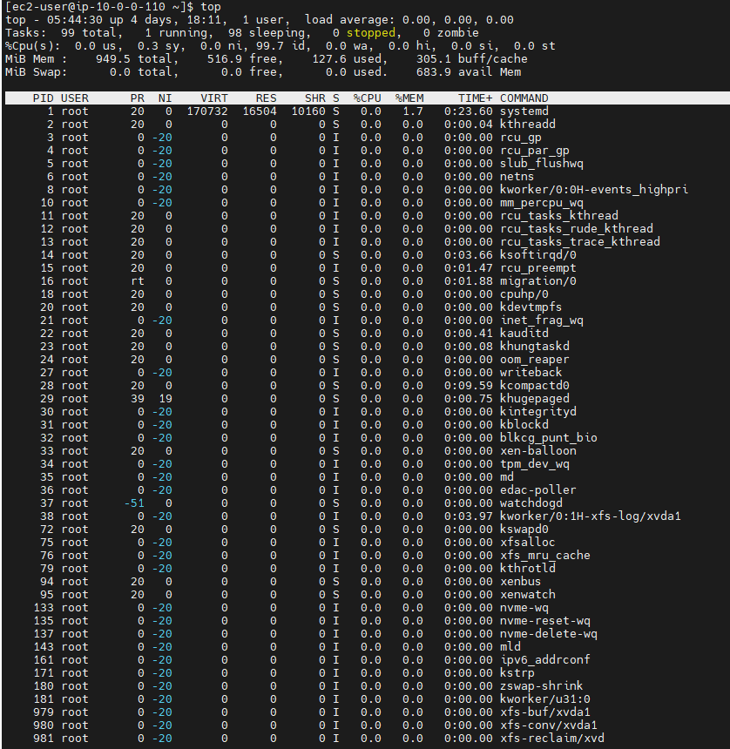

Checking if the port of guvi.com:9000 port is open or not

